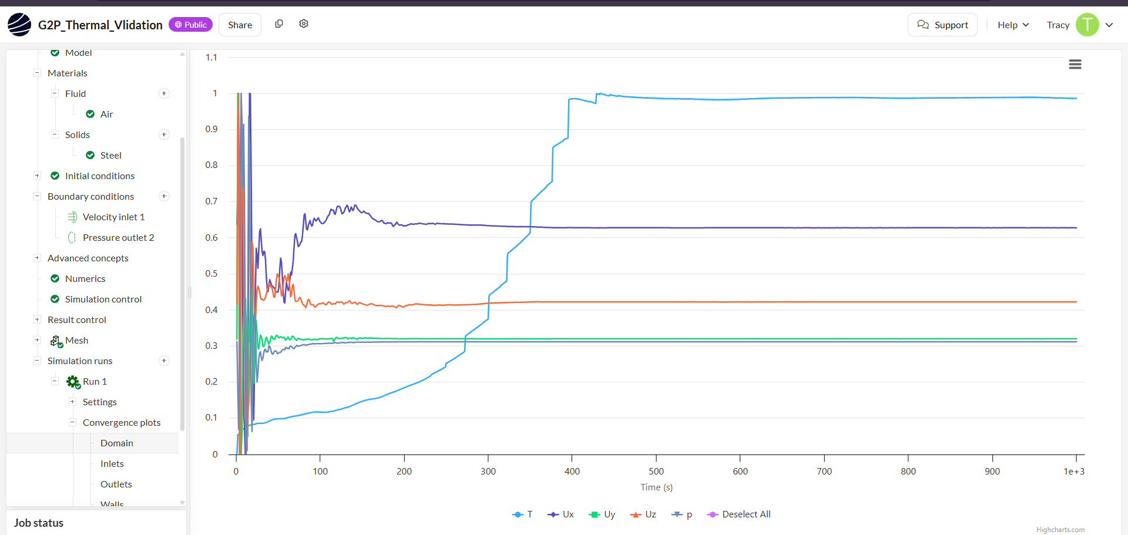
SIMSCALE CONVERGENCE PLOTS By Tracy Prest
Domain Plots

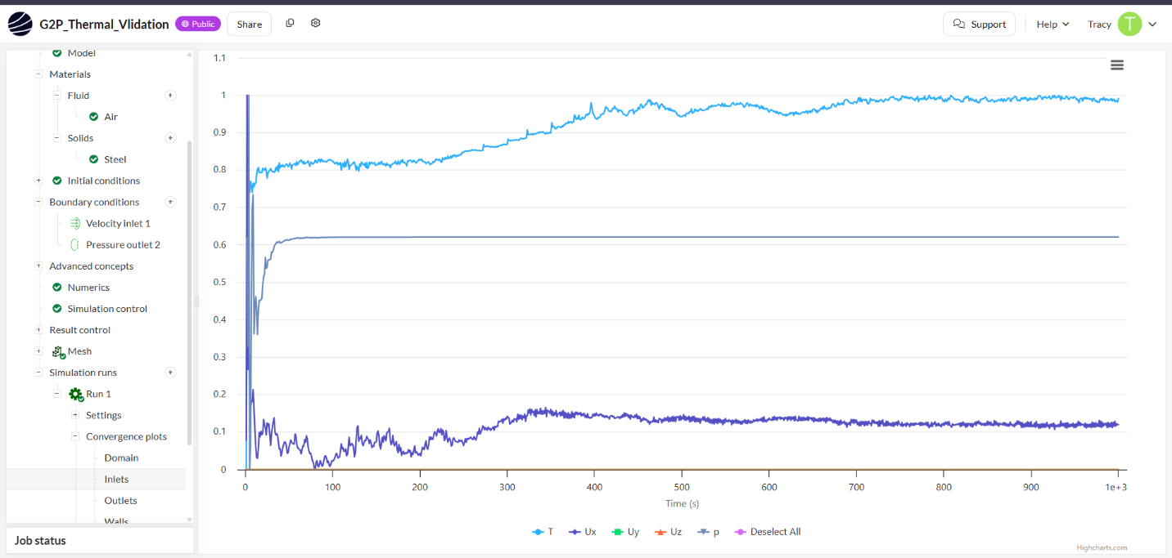
Inlet Plots
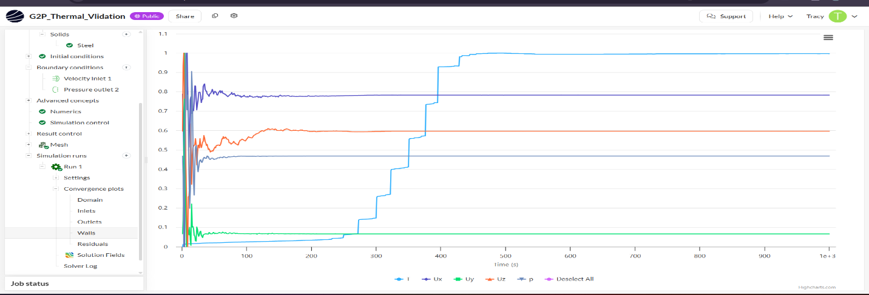
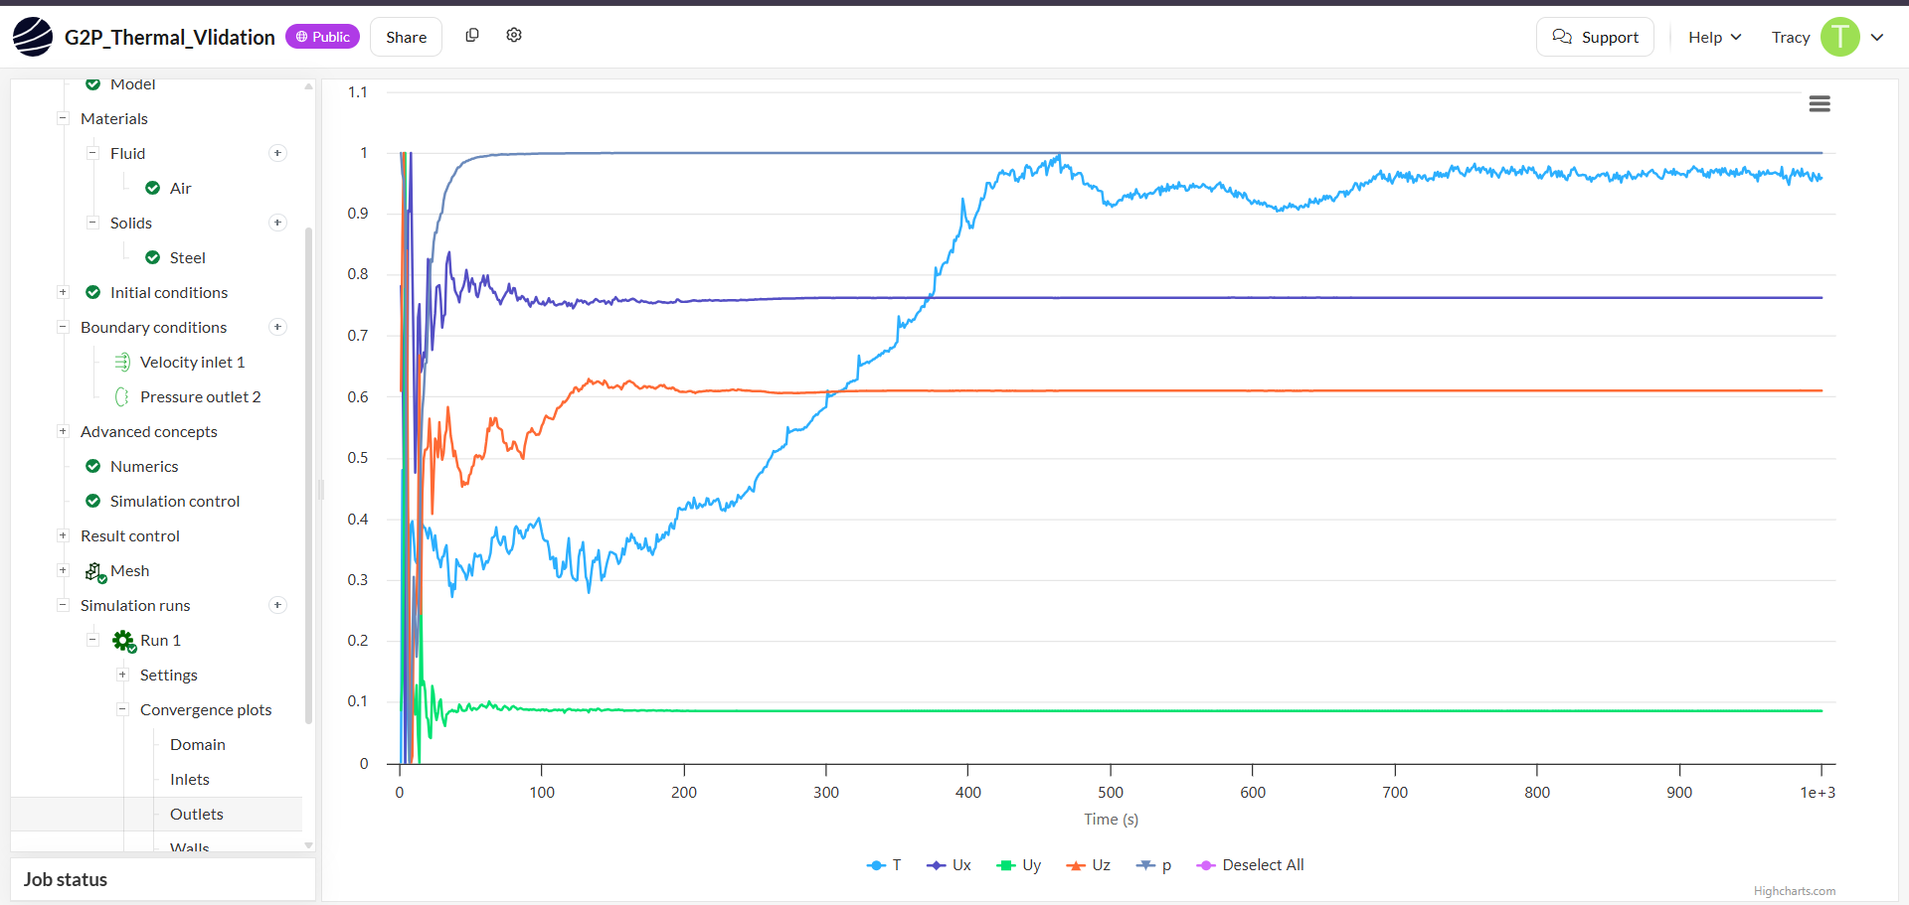
Outlets Plot
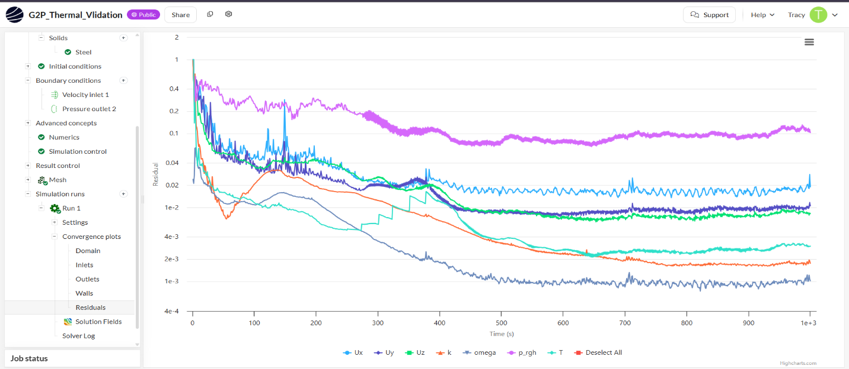
Walls Plots
Residuals Plots
The Residuals Plot
This is the most critical plot of the thermal validation because it tracks the mathematical error margin.
• Velocity & Pressure (Ux, Uy, Uz, p_rgh): The error lines for the moving air currents drop down sharply below 1× 10⁻² and stabilize. This confirms that the air sweeping around the engine block is perfectly balanced.
• Temperature (T): The light-blue thermal line drops the lowest, settling near 1× 10⁻³ and smoothing out into a perfect flat line. This proves that the thermal balance between the 306 kW engine heat source and the incoming 8 m/s fresh air current has completely stabilized.
The first four plots: Domain, Inlets, Outlets, and Walls shows the live physical readings inside your container across time:
From the right half of all four charts, the Temperature (T, light blue line), Pressure (p, dark grey line), and Velocity components flatten out completely.
This physics shows that after an initial turbulent start, the air flowing into the square inlet settles down into a steady, reliable cooling jet that cleanly carries the engine's heat straight out of the circular vent.

